Nigeria

## Respect for rule of law (ROL) data

The data set shows the data on the respect of the rule of law for the country.

## # A tibble: 19 x 5  
## country iso3c date ruleOfLaw ruleOfLawCategory4   
## <chr> <chr> <dbl> <dbl> <chr>   
## 1 Nigeria NGA 1996 -1.29 ROL highly disrespected   
## 2 Nigeria NGA 1998 -1.26 ROL highly disrespected   
## 3 Nigeria NGA 2000 -1.10 ROL highly disrespected   
## 4 Nigeria NGA 2002 -1.41 ROL highly disrespected   
## 5 Nigeria NGA 2003 -1.43 ROL highly disrespected   
## 6 Nigeria NGA 2004 -1.41 ROL highly disrespected   
## 7 Nigeria NGA 2005 -1.35 ROL highly disrespected   
## 8 Nigeria NGA 2006 -1.07 ROL highly disrespected   
## 9 Nigeria NGA 2007 -1.07 ROL highly disrespected   
## 10 Nigeria NGA 2008 -1.04 ROL highly disrespected   
## 11 Nigeria NGA 2009 -1.15 ROL highly disrespected   
## 12 Nigeria NGA 2010 -1.16 ROL highly disrespected   
## 13 Nigeria NGA 2011 -1.18 ROL highly disrespected   
## 14 Nigeria NGA 2012 -1.15 ROL highly disrespected   
## 15 Nigeria NGA 2013 -1.11 ROL highly disrespected   
## 16 Nigeria NGA 2014 -1.05 ROL highly disrespected   
## 17 Nigeria NGA 2015 -0.961 ROL moderately disrespected  
## 18 Nigeria NGA 2016 -1.02 ROL highly disrespected   
## 19 Nigeria NGA 2017 -0.866 ROL moderately disrespected

## Respect for rule of law (ROL) trend

The plot shows the trend of the respect for the rule of law for the country.

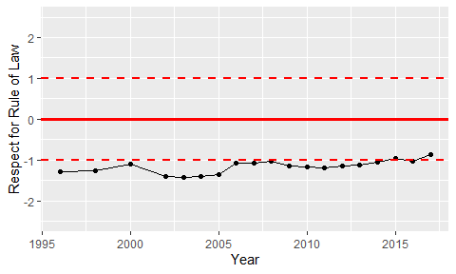

Trend of the Respect for the Rule of Law